Procedure to install PDF Camp Printer for Advantzware

- Install the software

  - Under pdfcamp directory find pdfcamp_enterprise.exe
  - Double Click to run the program
  - Do the default installation

- Change printer setting for Advantzware

  - Goto Start -> Settings -> Printers& faxes
  - Right Click on PDFCamp Printer and choose properties. Following dialog box will appear.
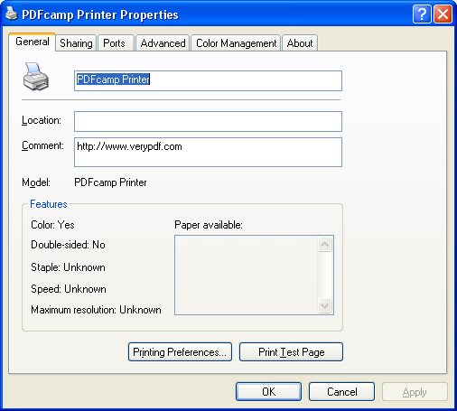

- Click on Printing Preferences

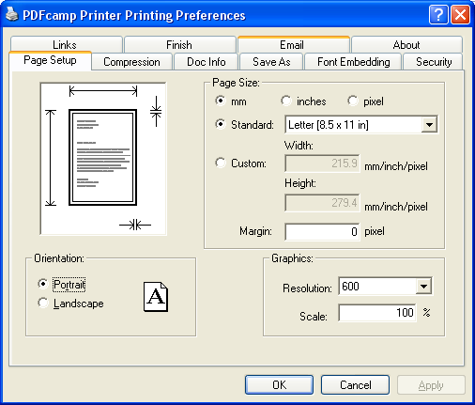

Make sure Paper Size selected is Letter(8.5 x 11in)

Click on Compression Tab and make sure settings are as follows
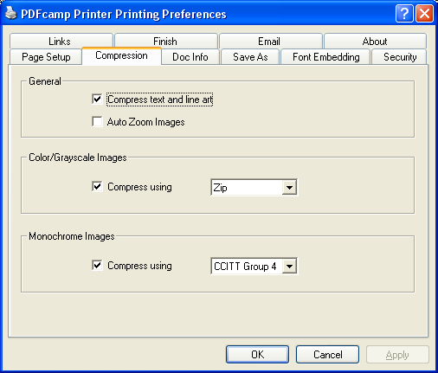

Click on SaveAs Tab and make sure the setting are as follows
  - Batch Output checked and in the box type – c:\tmp\asi.pdf
  - Make sure Overwrite if file exist is selected
  - Make sure View after Creation and Email after creation is turned off.

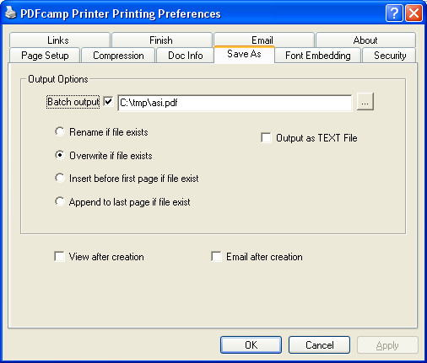
- Register the product
  - Click on About Tab
  - Enter Registration Code : 35V2X1B3U389PJ78
  - Click Register. If any error occurs contact Advantzware.

